The last Samurai
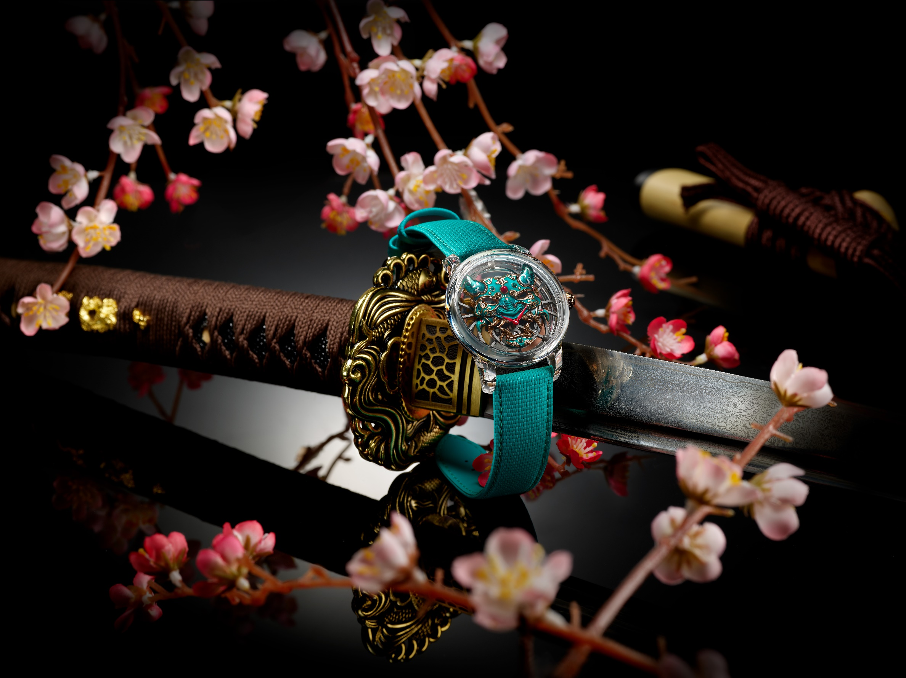
It has been ten years since Jaquet Droz turned its attention to the Japanese arts. Now, an exceptional piece revisits the theme, taking as its central motif the mask of the Japanese warrior and respectfully but freely interpreting its shapes and colours. More than half a dozen master craftspeople and 200 hours of work were required to bring this Tourbillon Skelet Sapphire – Bushidô Tourbillon to life. As always at Jaquet Droz, it will only be produced as a single unique piece.

If we say that the dial is the face of the watch, what could be more natural for a piece inspired by the Japanese arts than to feature the most famous face of the Archipelago, the mask of its Bushi warriors?
Known to the rest of the world as the Samurai, they have been part of Japanese mythology for thousands of years, occupying a realm where legend meets reality. In Japanese culture, masks are not solely an element of pageantry – think Noh (lyrical drama) or Kabuki (epic drama) theatre – and there are almost 140 officially recorded types of mask. But the Bushidô mask (literally: he who follows the way of the warrior) occupies a special place. It must embody the Samurai code of honour and its seven fundamental values*, assert the wearer's power, terrorise opponents, embody spiritual protection and offer the deference due to elders. To meet these needs, the Bushi warrior mask readily borrows certain codes from the gods and demons of the Japanese pantheon.
It is no easy task to translate such national wealth into a timepiece. To achieve this, Jaquet Droz had to call on most of its master craftspeople: engravers, painters, sculptors, enamellers, stone-setters, and more. The aim: to create the most powerful visual sensation possible.

Micro-sculpture takes centre stage. It is thanks to this that the Bushidô mask literally emerges in its three dimensions. The use of a 100% sapphire case gives the illusion of the mask being worn directly on the wrist. This case is a tour de force in itself: Unlike most equivalents on the market, the Tourbillon Skelet Sapphire - Bushidô is 100% Swiss Made, manufactured in La Chaux-de-Fonds, and has no screws or inserts. The view of the movement and dial is unobstructed.
It is this perfectly clear view that allows the most intricate details of the mask to be admired. Its main surface is hand-painted, but its horns are made of translucent enamel. None of the mask's surfaces are flat: The intaglio engraving on the red gold base underscores the eyes, nose and mouth, outlined in gold. In a first for Jaquet Droz, the face features a setting of Murano glass beads, accentuating both the dominant jade colour and the menacing accents of red also found on the two hand-painted hands.
The movement of the Bushidô watch is based on a Manufacture calibre. Its tourbillon, positioned at 12 o'clock, balances the barrel at 6 o'clock. The two parts can be seen from the back thanks to an openworked red gold oscillating weight, through which a unique feature can be admired: The back of the mask itself is hand-painted with sakura, or cherry blossom – a rare treat, as the reverse of appliques is usually polished but very rarely painted.
A unique timepiece measuring 42 mm in diameter with an 8-day power reserve, the Tourbillon Skelet Sapphire – Bushidô embodies the entire Jaquet Droz JD 8.0: A Disruptive Legacy philosophy: disruptive in its aesthetic treatment and sapphire case with a skeleton movement, but deeply respectful of the Japanese heritage it conveys.
*Integrity, respect, bravery, honour, compassion, honesty, loyalty

“Create your own. As unique as you are”

